Sennheiser Group brings audio galore to The 2024 NAMM Show
Visitors will be welcomed to experience the latest solutions from Sennheiser, Neumann, Dear Reality and Merging Technologies in two dynamic demo rooms

Wedemark/Anaheim, January 17, 2024 – The anticipation is building for this year’s NAMM Show as the Sennheiser Group prepares to showcase its latest audio innovations in two demo spaces. The Sennheiser Group Live Room (located in demo room # 18806) and the Immersive Demo Room (# 18808) promise an unparalleled experience for show visitors, featuring the latest audio innovations from Sennheiser, Neumann, Dear Reality and Merging Technologies, as well as offering seminars and panel discussions with some of the industry’s leading experts.

The Sennheiser Group Live Room (# 18806) will offer visitors a chance to explore the rich histories of Sennheiser and Neumann by showcasing both companies’ timelines. A focal point within the space will be the unveiling of Sennheiser’s latest addition to its professional studio portfolio, with NAMM attendees having the unique opportunity to engage with the product for the very first time.

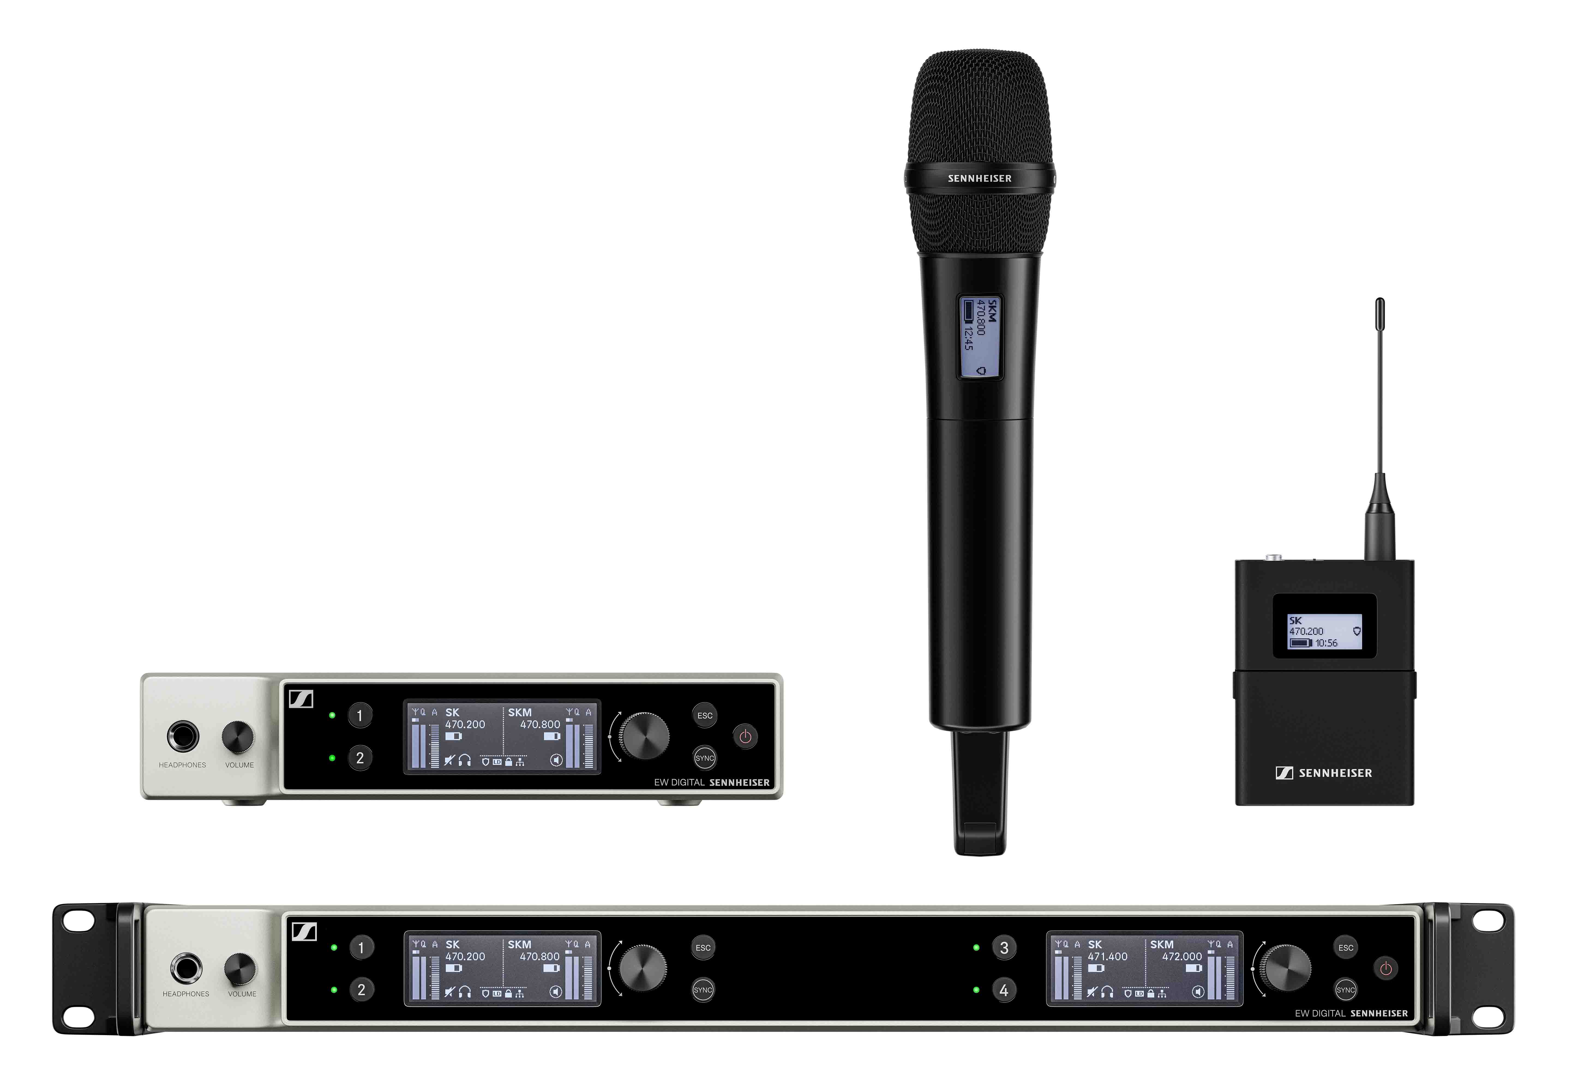 | Besides its wireless offer for musicians (pictured are transmitters and receivers of the EW-DX series), Sennheiser will unveil a new studio product

Additionally, a dedicated wireless station will feature the Evolution Wireless Digital family of wireless microphones, Digital 6000 wireless mics as well as XS Wireless IEM and evolution wireless G4 IEM systems.

An insulated “Whisper Room” will accommodate selected Neumann microphones for demo. Moreover, Neumann will announce three new products. The MT 48 audio interface will receive an eagerly anticipated feature update, which, among other things, will allow working in immersive audio formats. Another focus is live sound: Neumann will show an omni capsule for the Miniature Clip Microphone (MCM) system as well as goosenecks of various lengths. Also on display will be much-requested additions to Neumann’s renowned family of vocalist capsule heads for wireless systems.

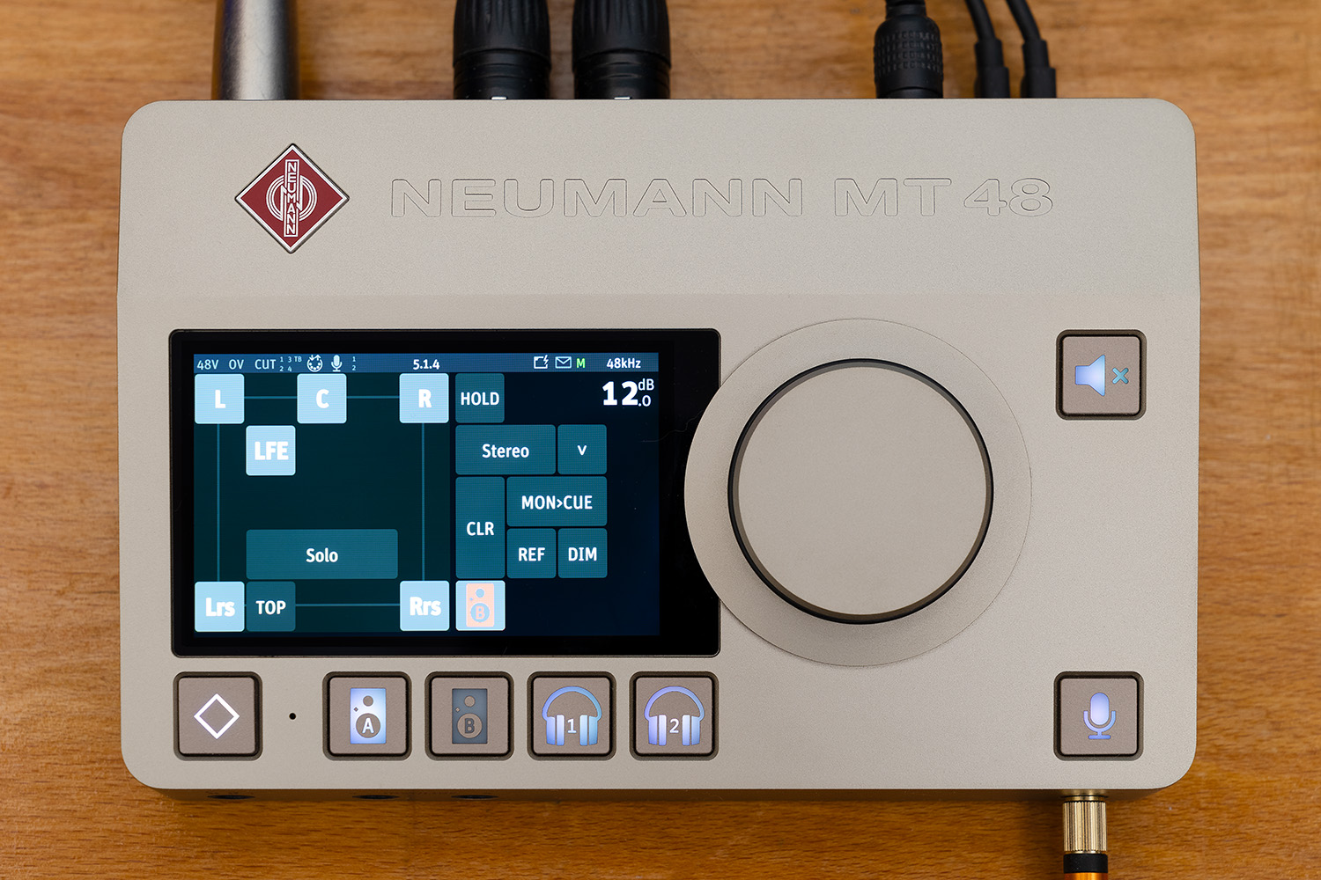 | The Neumann MT 48 audio interface will receive a feature update, which will allow working in immersive audio formats

Two workstations will offer a hands-on experience of accessible immersive workflows. Here, spatial audio expert Dear Reality will introduce the successor of its popular dearVR PRO immersive spatializer plugin, dearVR PRO 2. This plugin adds another layer of spatial experience to any professional audio production and puts the listener at the center of the sound.

Dear Reality will introduce dearVR PRO 2, the successor to its popular dearVR PRO immersive spatializer plugin | 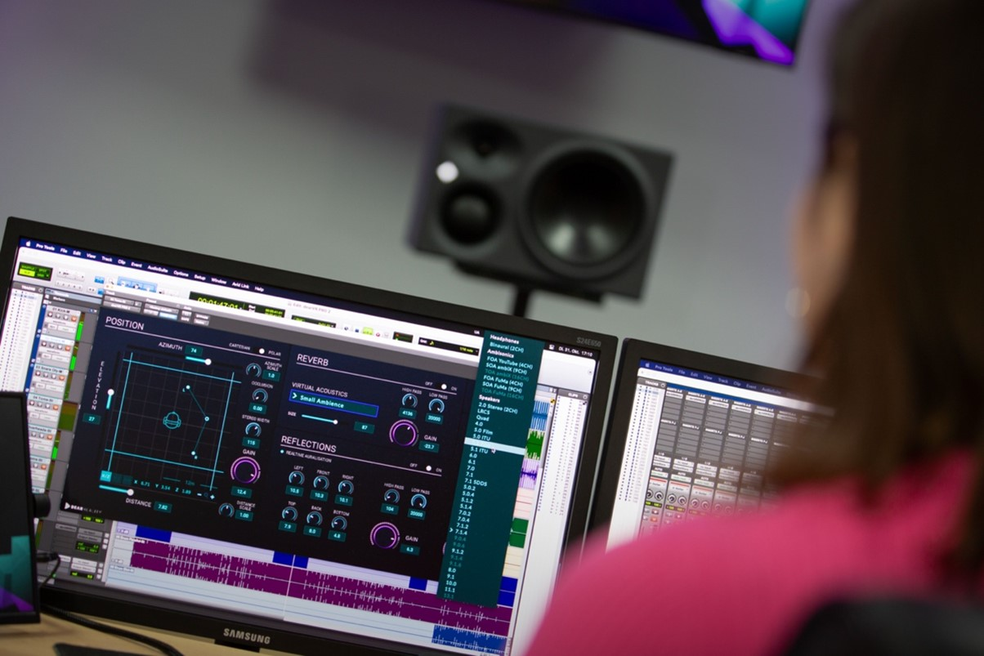

Furthermore, visitors can experience solutions to control the DAW in VR with Dear Reality’s dearVR SPATIAL CONNECT as well as monitor spatial audio mixes through headphones with the dearVR MONITOR mix room plugin.

The second immersive workstation will showcase Merging Technologies audio interfaces. A highlight will be the company’s Venue Mission software for the Anubis audio interface, which is set to revolutionize workflows for live musicians and sound engineers, providing them with unprecedented control over the entire audio ecosystem via an intuitive user interface that has a full 16-channel mixer at its heart.

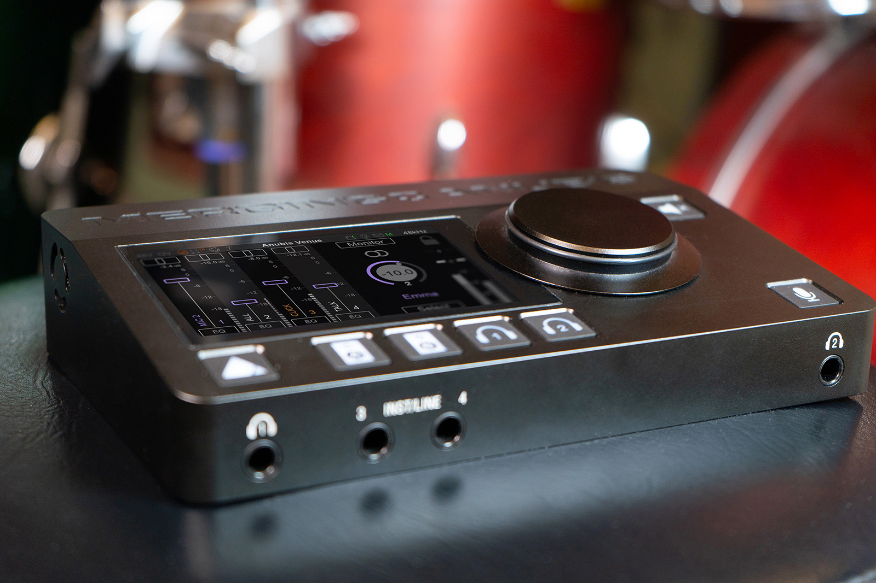 | Merging Technologies will showcase its Venue Mission software and its personal mix for musicians

In addition to product demonstrations, the Sennheiser Group Live Room features a stage with daily seminars led by industry luminaries. Monitor engineer Salim Akram, Grammy & Emmy awarded broadcast audio producer-mixer Michael Abbott, mixing engineer Brandon Blackwell, Sennheiser’s Jimmy Landry as well as music producers Mark Needham and Daniel Rowland will share insights on topics ranging from navigating a journey in live audio to the role of AI in music production. A panel discussion with top music industry creators including Sean Daniel (@sean_daniel_music), Steve Onotera (@samuraiguitarist), John Matos (@abioticjohn), Emily Harris (@GetOffset) and Larry Orsini (@larryohh), as well as a closing session with Blake Shelton’s drummer Tracy Broussard will further enrich the NAMM Show experience.

Meanwhile, the Immersive Demo Room (# 18808) will captivate audiences with immersive presentations utilizing Neumann KH monitors as well as Merging Technologies’ Anubis and Hapi MK II audio interfaces configured in a 9.1.6 and 360 RA immersive sound setup. The Neumann Soundstage will feature masterclasses by renowned music producers and engineers such as Ronald Prent, Eva Reistad, Matt Wallace, Will Kennedy, Elliot Scheiner, Gavin Lurssen, Reuben Cohen, Michael Romanowski, Jimmy Douglass, Chuck Ainlay, George Massenburg, Jim Anderson, Ulrike Schwarz, Eric Schilling, Herbert Waltl, Frank Filipetti, Sylvia Massey and Justin Gray.

“At Sennheiser, we're excited to collaborate with some of the brightest stars in the industry and invite them to share their knowledge at this year's NAMM Show,” says Ed Capp, Sales Director Americas. “This promises to be an exciting event, featuring the unveiling of a brand-new studio product and showcasing a selection of top solutions from the Sennheiser Group, all available for demos and testing by show visitors. Be sure to stop by demo rooms 18806 and 18808 for an unforgettable audio experience!”

Visit the Sennheiser Group at NAMM in the Sennheiser Group Live Room (18806) and the Immersive Demo Room (18808).

(Ends)

The high-resolution images accompanying this media release can be downloaded here.

About the Sennheiser Group

Building the future of audio and creating unique sound experiences for our customers - this is the aspiration that unites the employees of the Sennheiser Group worldwide. The independent family-owned company Sennheiser was founded in 1945. Today, it is managed in the third generation by Dr. Andreas Sennheiser and Daniel Sennheiser, and is one of the leading manufacturers in the field of professional audio technology.
sennheiser.com | neumann.com | dear-reality.com | merging.com

